* 1. C)

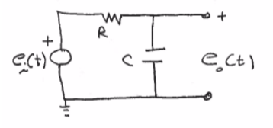Given:

Using KVL:

$$e_{i}\left(t\right)-Ri\left(t\right)-\frac{1}{C}\int{i\left(t\right)dt}=0$$

$$e_{o}\left(t\right)=\frac{1}{C}\int{i\left(t\right)dt}$$

Solve for an equation between $e_{o}\left(t\right)$ and $e_{i}\left(t\right)$:

$$Ce_{o}(t)=\int{i\left(t\right)dt}$$

$$\frac{d\left(Ce_{o}\left(t\right)\right)}{dt}=i(t)$$

$$e_{i}\left(t\right)-RC\frac{de_{o}\left(t\right)}{dt}-\frac{1}{C}\int{\frac{d\left(Ce_{o}\left(t\right)\right)}{dt}dt}=0$$

$$e_{i}\left(t\right)=RC\frac{de_{o}\left(t\right)}{dt}+e_{o}(t)$$

D)

From data: Resistance for circuit $R_{1}=11.1 kΩ$

Sample calculation: $τ=R*C$, $6.68155e^{-4}=11.1e^{3}*C$, $C=5.82e^{-8}F$

|  |  |  |
| --- | --- | --- |
| Method | Tau Adjusted (s)* | Calculated Capacitance (nF) |
| Output 1 Initial Slope | 6.68155e-4 | 60.19 |
| Output 1 63.2% | 6.54000e-4 | 58.92 |
| Output 2 Initial Slope | 6.35428e-4 | 57.25 |
| Output 2 63.2% | 6.52000e-4 | 58.74 |
| Average |  | 58.77 |

*Adjusted Tau is the value found taken into account that the data did not start at time = 0.